Dear Parent/Carer,
Welcome to the new academic year. Your child is about to embark upon an exciting new stage in their education and we are very much looking forward to working with and teaching them this year.
You will be aware the internet hosts many exciting opportunities for education. The online world is a wonderful place for young people to explore, with unprecedented opportunities for learning and creativity, but just like the real world there are risks and dangers they should be aware of and which we should all act to protect them from. As a school we encourage the use of technology as an important part of our students’ development but always want them to spend their time online safely. As a parent/carer you can play a significant part in ensuring this.
Just a few simple steps by you can help keep them safe and give young people the awareness to know what to do if they feel uncomfortable about anything they encounter while on the internet.
If you do not wish for your child to be able to access any inappropriate content online, please ensure that their computers, laptops and other devices with internet access are all fitted with parental controls.
You can find free downloadable versions online or you can contact your internet service provider (such as BT, Talk Talk, Sky) for more information.
As a minimum, please set parental controls on your search engines, youtube account and the mobile phone your child uses.
One of the most popular search engines in the world is Google. You can visit Google’s informative safety centre for simple step by step guides - www.google.com/familysafety/tools
Here are a few options available to you; they truly are simple to set, promise.
Visit the Google home page – www.google.co.uk and click on the ‘search setting’ tab in the top right hand corner.
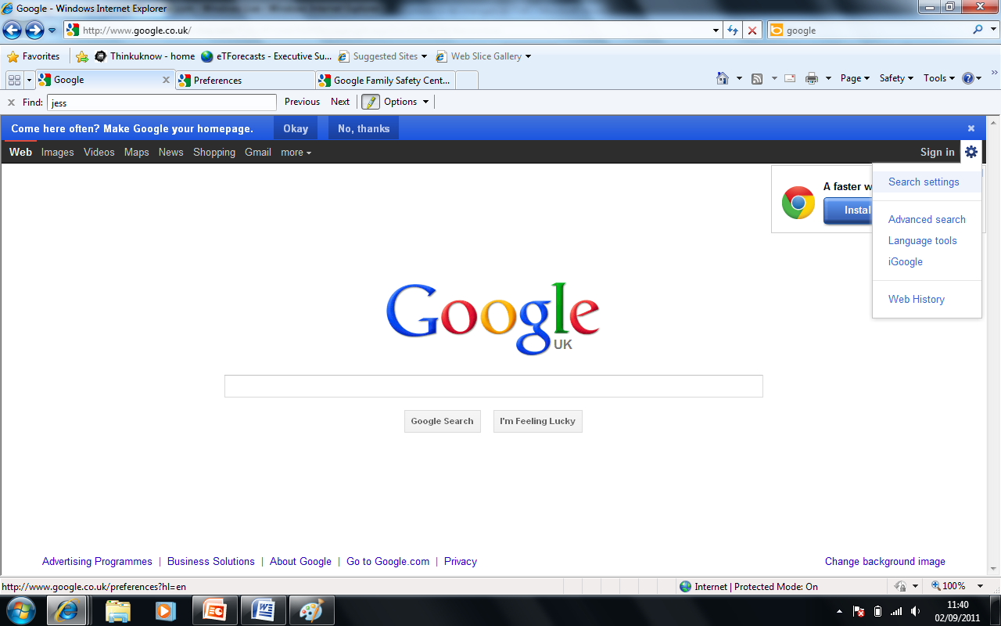
Scroll down the page and change the filtering options to suit your family’s needs. Make sure you lock the safe search; otherwise these settings can easily be changed without your knowledge.
You can also set this on your child’s smart phone;
Please be aware that no filter is 100% accurate. CEOP advice that you talk to your child about the sites they use. Why don’t you discuss:
- Their favourite online sites
- What they enjoy most, the fun aspects of being online?
- What they think can go wrong?
- How would they react if things got out of control?
Let them know that you understand that situations happen online and that seeing ‘adult’ material can make them feel uncomfortable. Make sure they know that you are there to help.

Visit The Child Exploitation and Online Protection Centre (CEOP) parents’ information website for more information - www.thinkuknow.co.uk/parents

