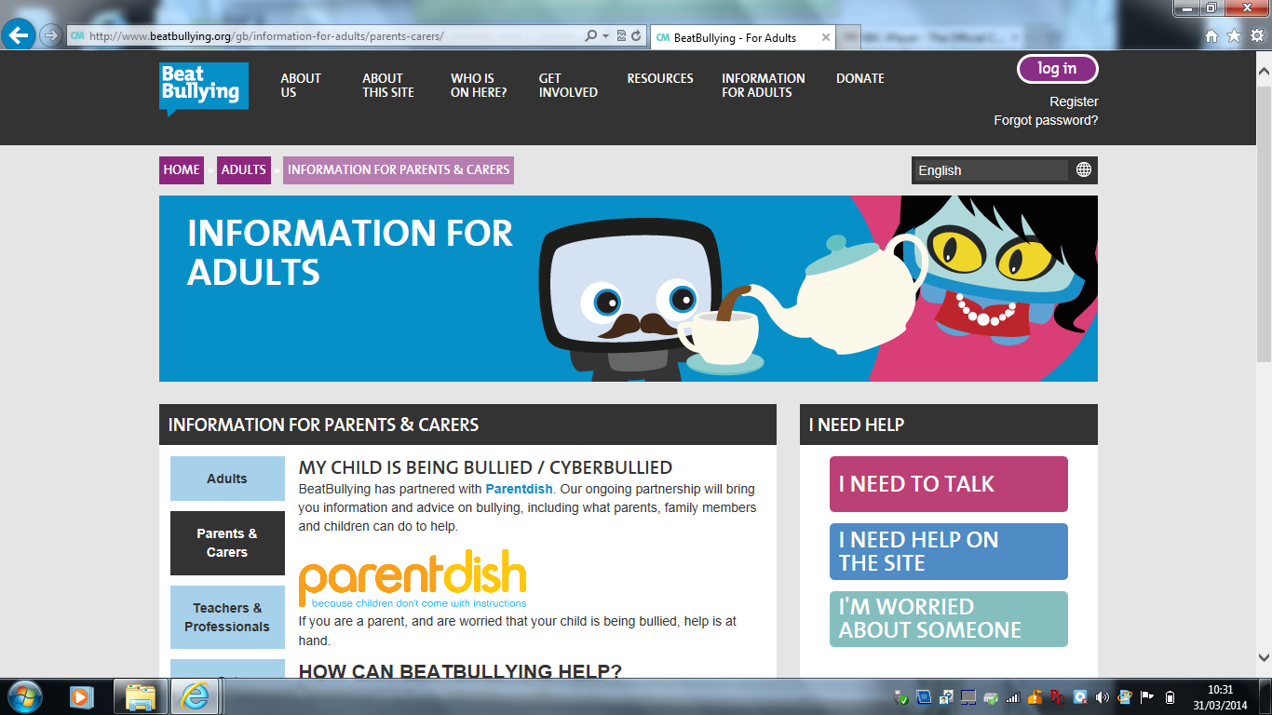
http://www.beatbullying.org/gb/information-for-adults/parents-carers/

