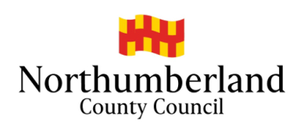

Northumberland Pupil Referral Unit
Hepscott Park
Stannington
Morpeth
NE61 6NF

www.pru.northumberland.sch.uk

28th September 2020

Dear Parent/Carer

Given the current deteriorating situation with the spread of coronavirus in Northumberland, the wearing of face coverings by children and young people aged over 11 on dedicated school transport has now been made mandatory. If your child is aged over 11, they must now wear a face covering when on dedicated school transport, in the same way as is required on public transport.

A face covering is a covering of any type which covers your nose and mouth and fits securely round the side of the face.

The usual exemptions from wearing a face covering still apply as for public transport, i.e. if your child has a physical or mental illness or impairment, or a disability that means they cannot put on, wear or remove a face covering.

Children under the age of 11 do not have to wear a face covering, however they may wear a face covering if they are able to handle it as directed.

Making wearing face coverings mandatory for children over 11 at this time is felt to be an important additional measure to help keep children and everyone they come into contact safe from COVID-19. We would be grateful if you can please emphasise to your child the absolute necessity of complying with this requirement.

Your active co-operation in this matter is of the utmost importance.

Thank you

School Transport Team

March 2019

Tel: 01670 514963 Email: admin@pru.northumberland.sch.uk

